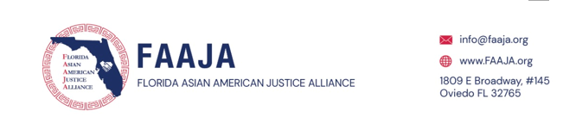

FACEBOOK | INSTAGRAM | YOUTUBE | TIKTOK

Florida Asian American Justice Alliance (FAAJA) joins many other civil rights and humanitarian organizations in condemning the senseless murder of Angela Michelle Carr, Jerrald De’Shaun Gallion, and Anolt Joseph Laguerre, Jr. in a Dollar General store in Jacksonville, Florida on Saturday, August 26, 2023. These hate crimes took place the same day that thousands gathered in front of the Lincoln Memorial in Washington, D.C. for the 60th anniversary of the March on Washington. While young blacks in Washington, DC held up signs stating, “I Am The Dream”, these three blacks in Jacksonville were brutally murdered. Black lives do matter, and these types of killings and hate must stop.

FAAJA wishes to extend our condolences to the families and friends of these and all victims of racially motivated murders and hate crimes. Our hearts not only go out to the families and friends of these shootings but also to the entire New Town community as well as the City of Jacksonville along with our sincere hope that the healing begins soon.

